



Sandwiches Rolls & Wraps

Ingredients
Choose from Ham, Chicken, Egg, Lettuce, Tomato, Carrot, Cucumber, Beetroot, Avo and Onion.
Sandwiches $5.50
Rolls $6.50
Wraps $6.00

Cold Cabinet
Chicken Salad Bowl/Ham Salad Bowl $7.00
Mexican Chicken Salad $7.00
Chicken Caesar Salad $7.00
Pasta Salads $5.00
Cheesecakes asst flavours $5.00
Yoghurt W/Granola $4.50
Tiramisu $5.00
Jelly $2.50
Jelly and custard $3.00
Custard $3.00
Flavoured Mousse $3.50
Asst Chocolates Bars $2.50

METRO CANTEENS
Woodridge State High School

THE BAKERY

Cookies $3.00
Muffins - Medium/Large $3.00/$4.50
Brownie Slice $4.00

Hot Box
Chicken W/Cheese $6.50 Chicken W/Lettuce $6.50
Spicy Chicken $6.50
Sweet Chilli Chicken Wrap $6.50
Cheeseburger $6.50
Bacon and egg Burger W/Hollandaise $6.00
Pizzas $5.50
HotDogs $5.50
Chicken Gravy Roll $5.50
Sausage rolls $5.00
Pies $5.00
Chips $4.00 W/Gravy $4.50
Wedges $4.00 W/Gravy $4.50
Gems $4.00 W/Gravy $4.50
Garlic Bread $2.50

Canteen Price List
Prices effective from NOV 2023
*Price subject to change at any given time

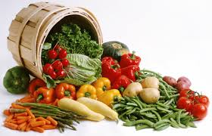

MEAL OF THE DAY
ALTERNATES EACH DAY

Pasta Dishes
Spaghetti Bolognese $6.50
Sausage, Mash, Veg $6.50
Chinese Chicken Noodle Stirfry $6.50
Butter Chicken $6.50
Nachos $6.50

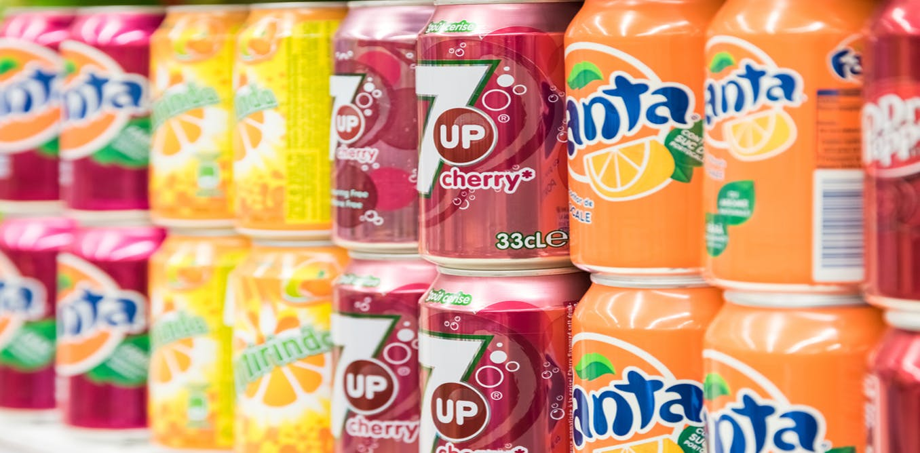

DRINKS

ICE BREAK /
FLAVOURED MILK -$5.00
GATORADES -$5.00
ICE TEA - $5.00
600ml SOFT DRINKS - $4.50
CAN SOFT DRINKS - $3.00
WATER -$3.00
SLUSHIE -$3.00

*Prices subject to change at any given time

STUDENTS WELCOME TO PRE-ORDER IN THE MORNINGS IF YOU WANT SOMETHING SPECIFIC OR DON’T WANT TO MISS OUT ON YOUR FAVOURITE FOOD
😊
CANTEEN LADIES
PENELOPE AND RENEE

ICE CREAM PRICES

ASST ICE CREAMS (SEE FREEZER)
$2.00 - $5.00
FROZEN FRUIT CUPS APPLE/ORANGE/APPLE BLACKCURRANT
$2.00
ZOOPER DOOPERS
$1.00


